JAWABAN TUGAS PENDAHULUAN MODUL 1

1. Kode :

Hasil :

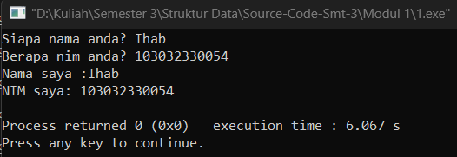

1. Kode :

Hasil :

1. Kode :

Hasil :

1. Kode :

Hasil :

1. Kode :

Hasil :

1. Kode :

Hasil :

1. Kode :

Hasil :

